**Experiment 5**

**Student Name: Jitesh Kumar UID: 20BCS2334**

**Branch: CSE Section/Group: 903- A**

**Semester: 5th Date of Performance: 28/09/2022**

**Subject Name: Machine Learning Lab Subject Code: 20CSP-317**

1. **Aim/Overview of the practical:**

Implement Naïve Bayes on any dataset.

1. **Code and Output:**

**#Harsh Pratap Singh**

**#20BCS5370**

**from sklearn.datasets import load_iris**

**from sklearn.model_selection import train_test_split**

**from sklearn.naive_bayes import GaussianNB**

**X, y = load_iris(return_X_y=True)**

**X_train, X_test, y_train, y_test = train_test_split(X, y, test_size=0.2, random_state=0)**

**gnb = GaussianNB()**

**nb = gnb.fit(X_train, y_train)**

**y_pred = nb.predict(X_test)**

**y_pred**

**y_test**

**print(nb.score(X_test, y_test))**

1. **Result/Output:**

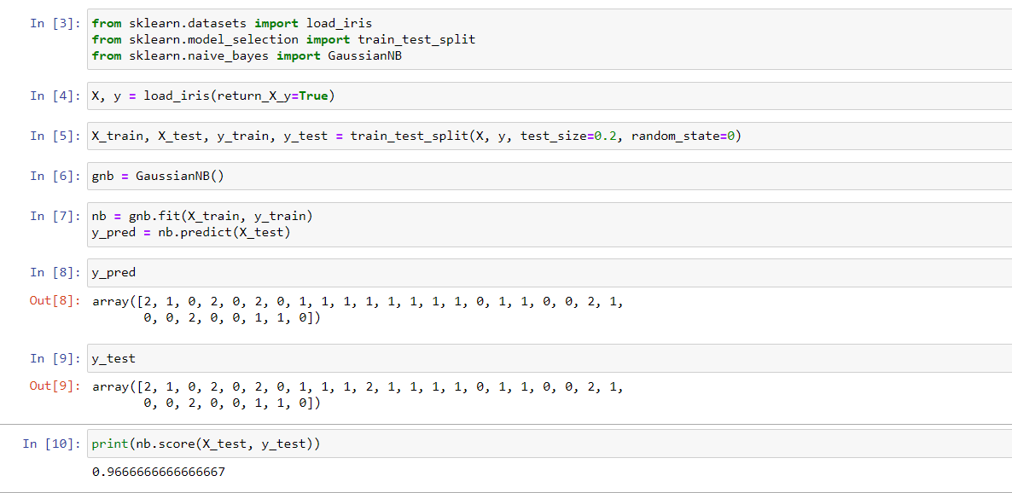

**Learning outcomes:**

1. Understood implementation of Naïve Bayes.

**Evaluation Grid:**

| **Sr. No.** | **Parameters** | **Marks Obtained** | **Maximum Marks** |
| --- | --- | --- | --- |
| **1.** | **Student Performance (Conduct of experiment) objectives/Outcomes.** |  | **12** |
| **2.** | **Viva Voce** |  | **10** |
| **3.** | **Submission of Work Sheet (Record)** |  | **8** |
|  | **Total** |  | **30** |